# **Case Study – Pixogram**

# **Jasmine Rengaraj (jasmir10@in.ibm.com)**

Spring boot Microservices for Pixogram:

1. netflix-eureka-server
2. usernamanagement
3. mediaservice
4. followservice
5. cloud-config-server

Angular11 – Pixogram User Interface

1. PixogramUI

Database – MySql

# **Screens**

## Eureka Server

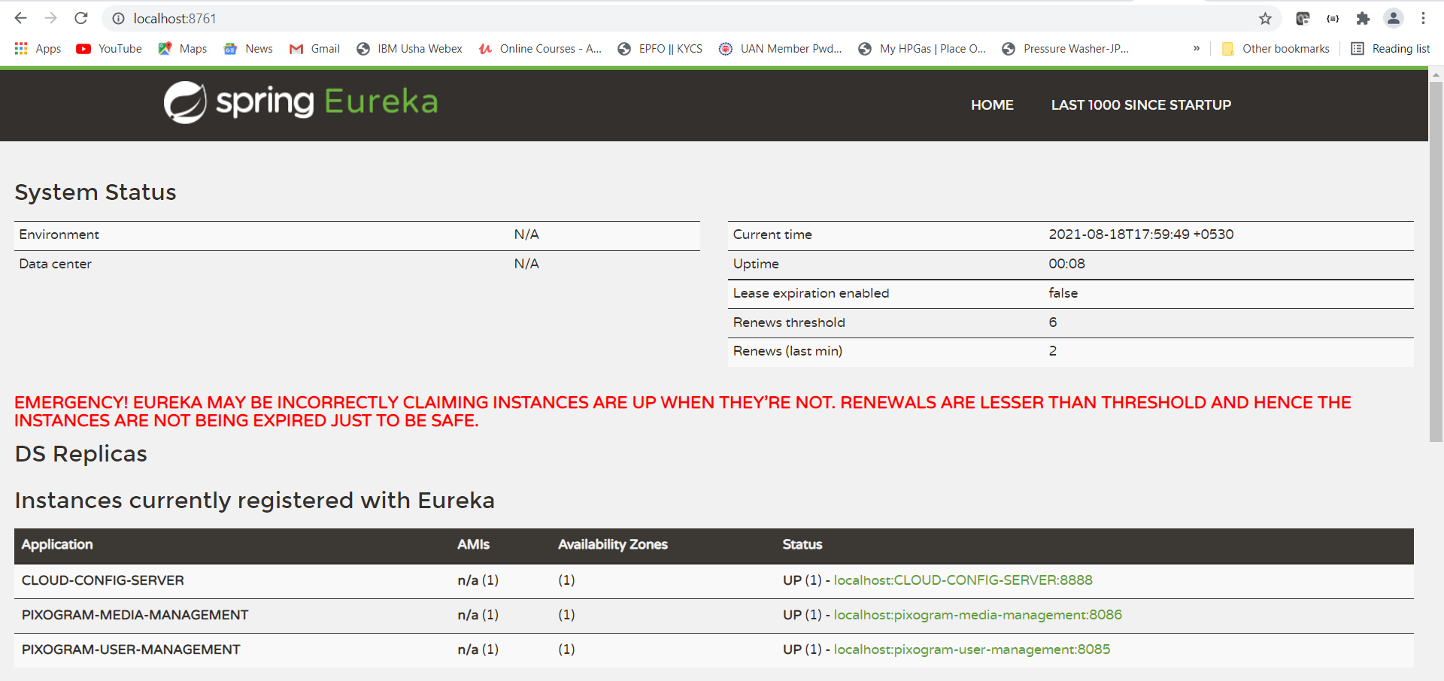

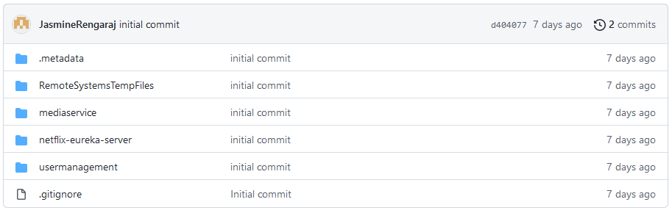

## **Database Schema Details**

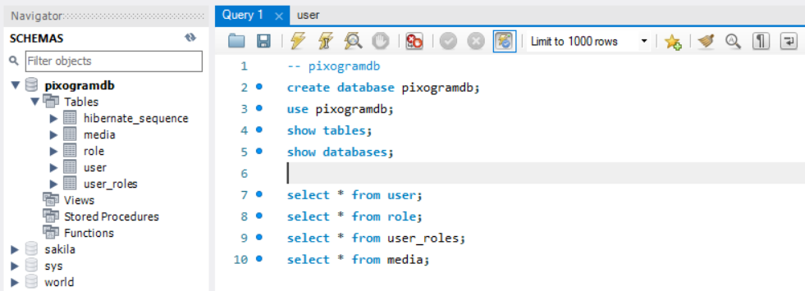

**describe user;**

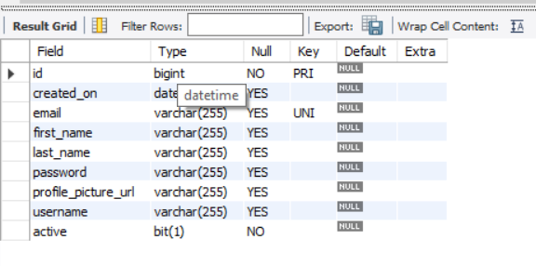

**describe role;**

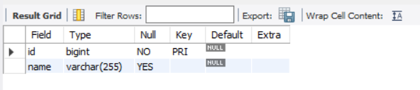

**describe user_roles;**

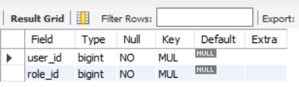

**describe media;**

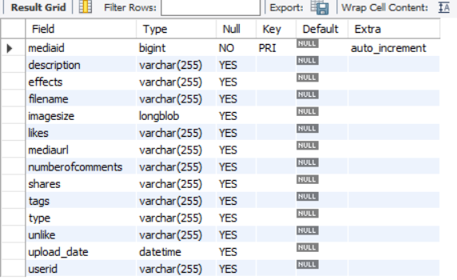

**select * from user;**

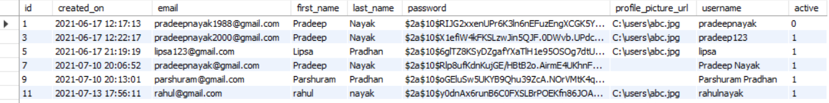

**select * from role;**

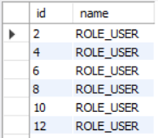

**select * from user_roles;**

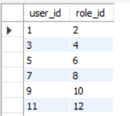

**select * from media;**

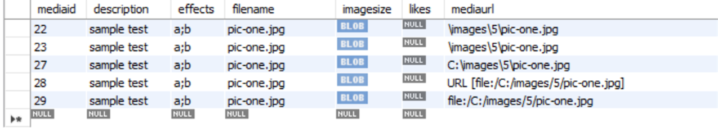

# **Usermanagement module screen shots**

**No Input or Invalid Login**

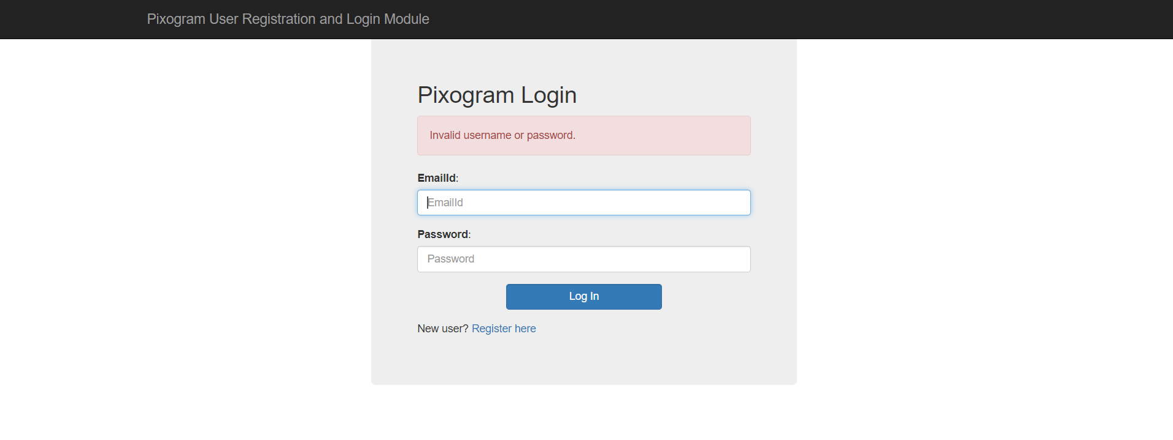

**Successful Login**

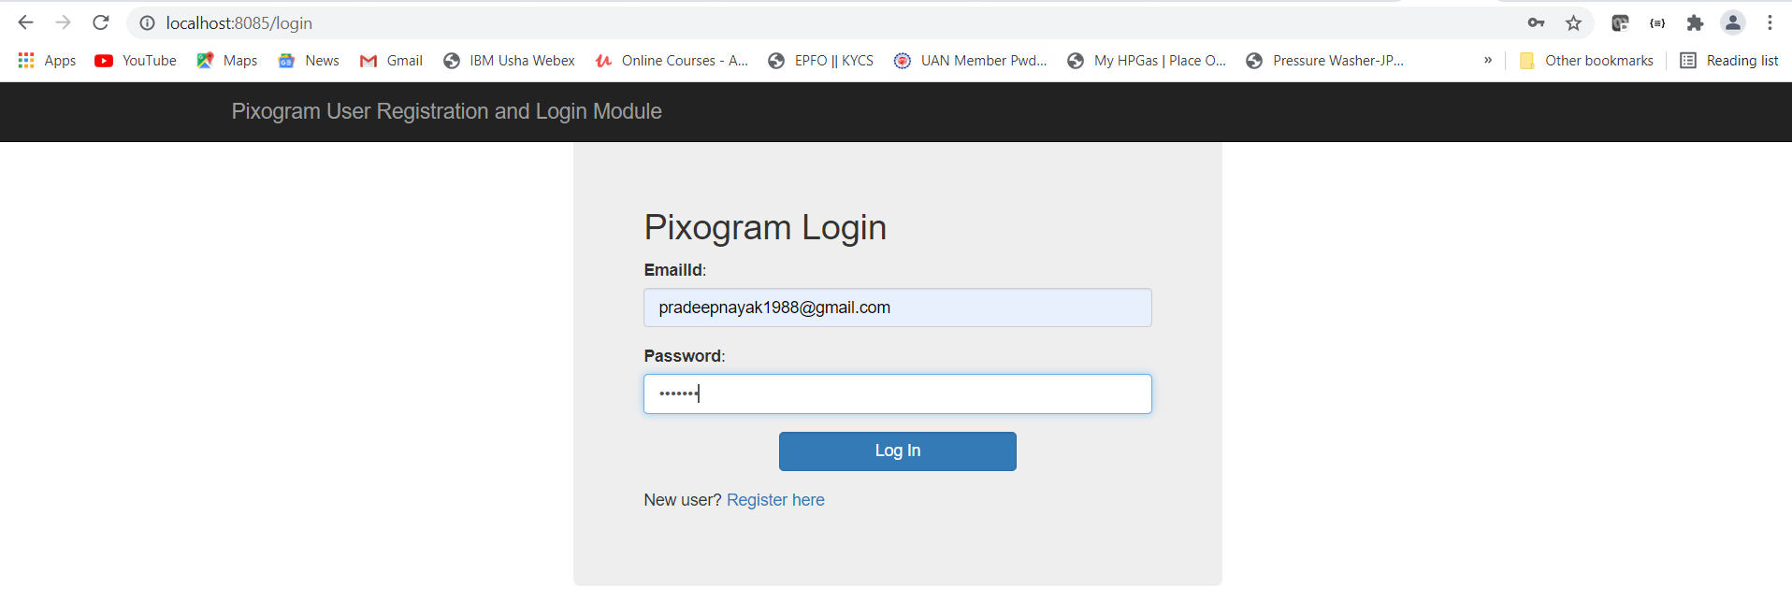

**Home Page**

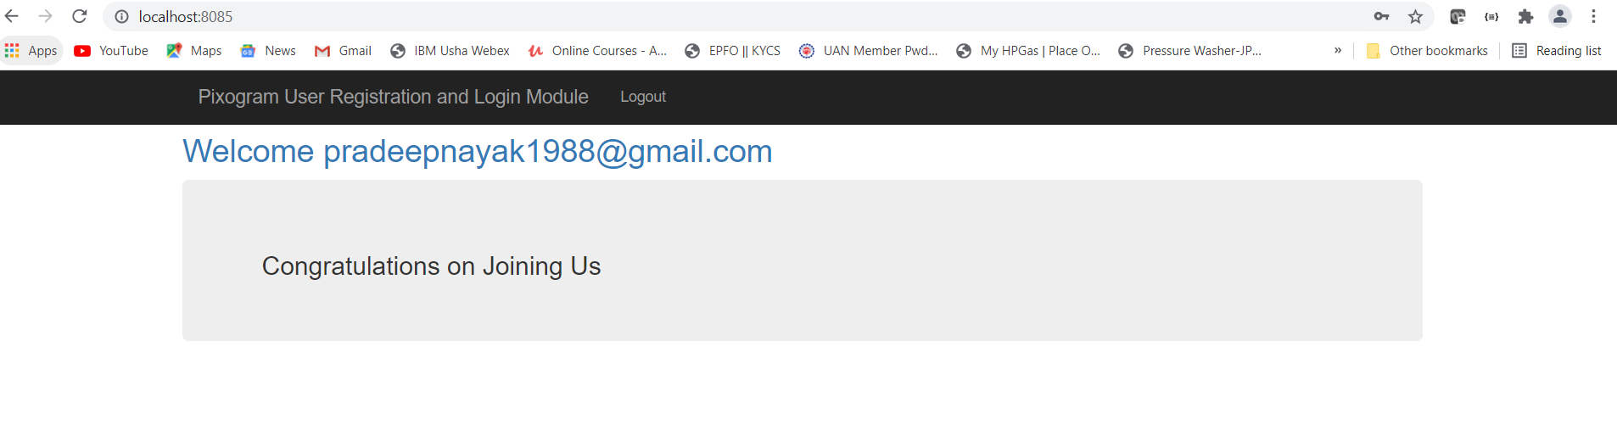

**Logout Successful Page**

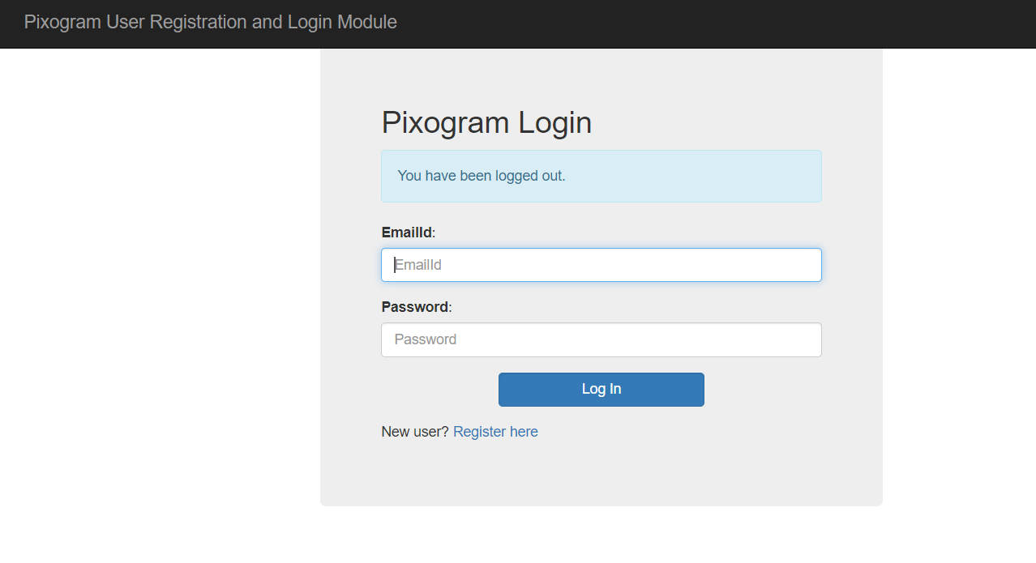

**User Registration Page**

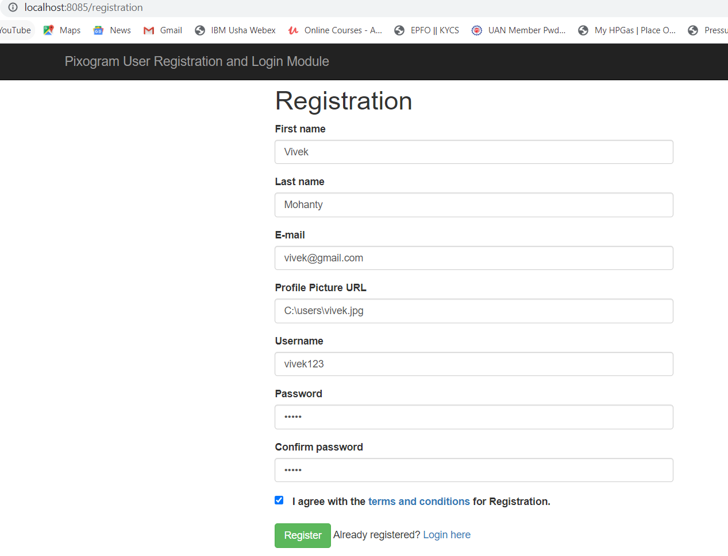

**Successful Registrarion**

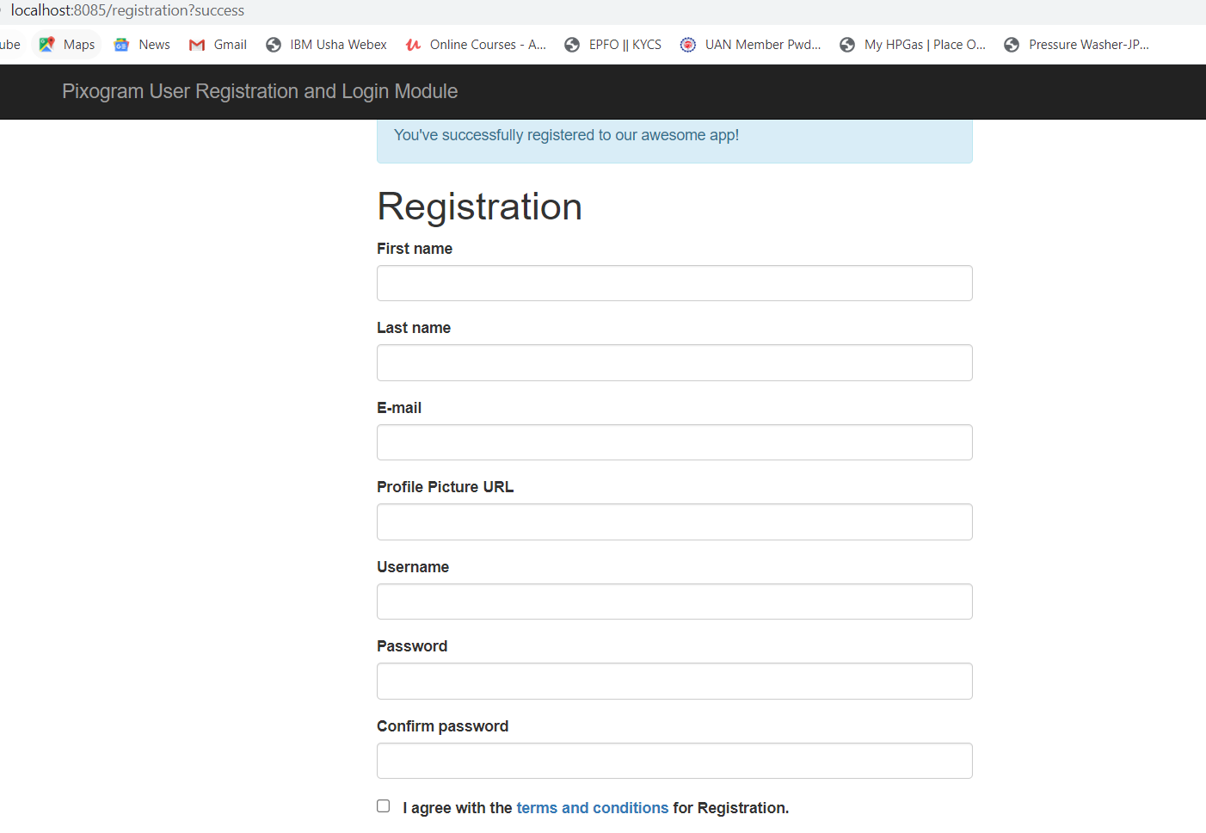

**JWT Authentication Token generation**

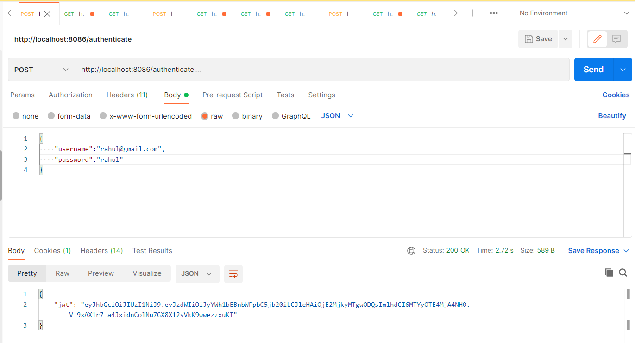

**Passing JWT Auth Token to access media service End Points**

**Invalid Authentication Token Forbidden Error**

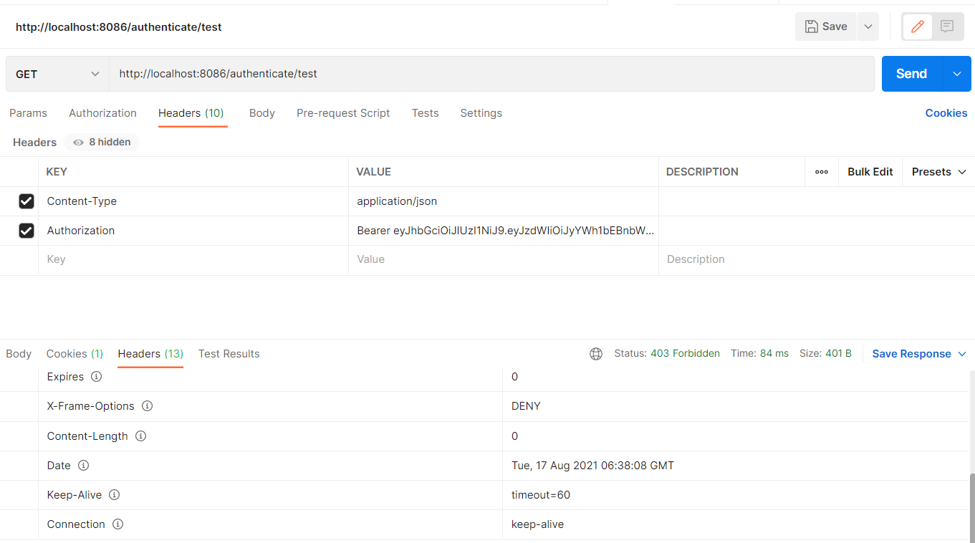

**Angular UI Snap shots**

**Login Screen**

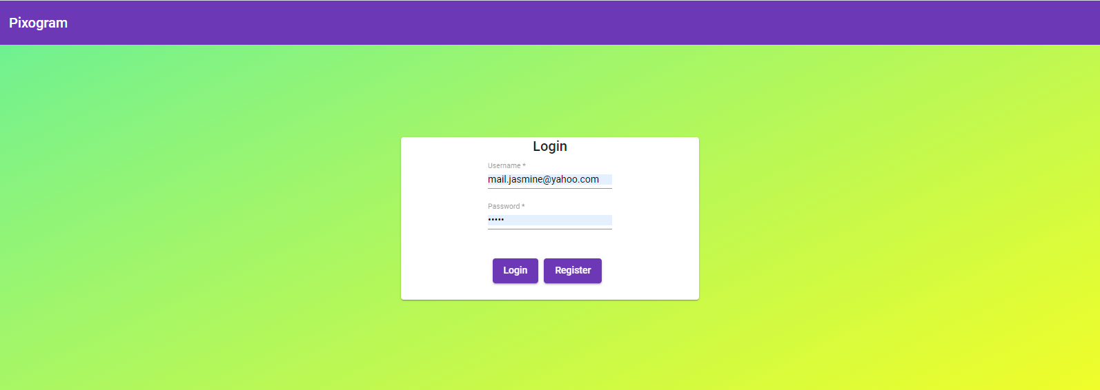

**Upload Media Page**

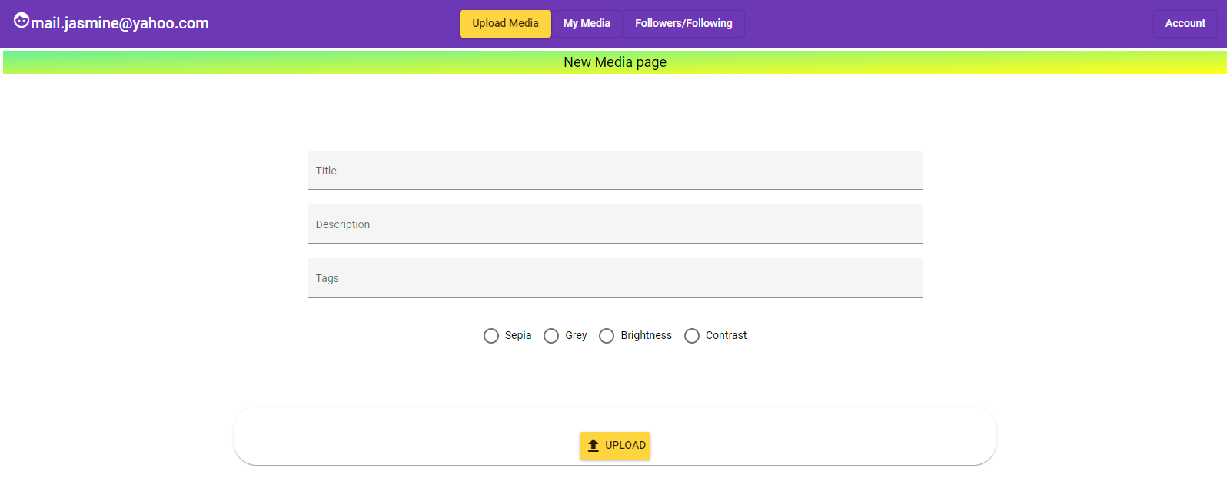

**Image Uploads**

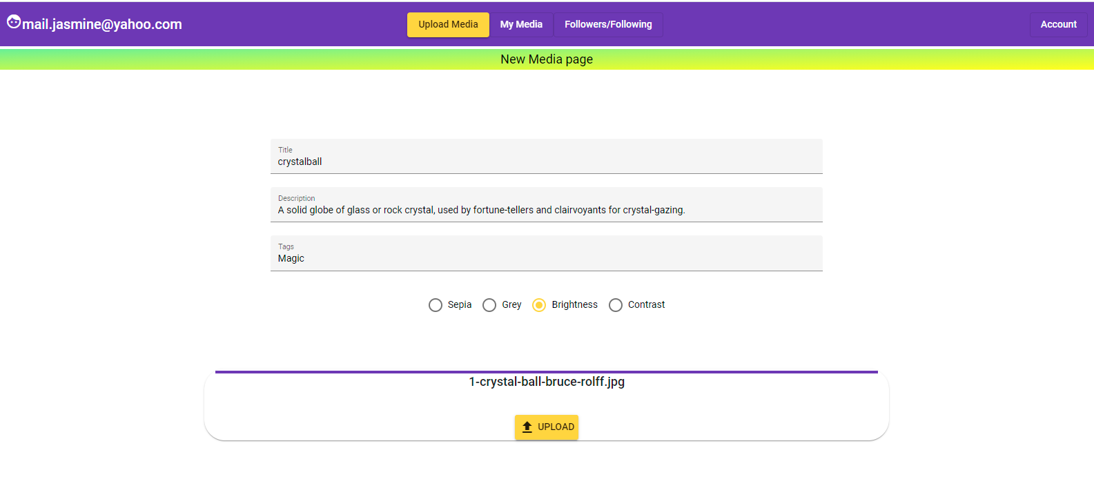

**Mymedia page**

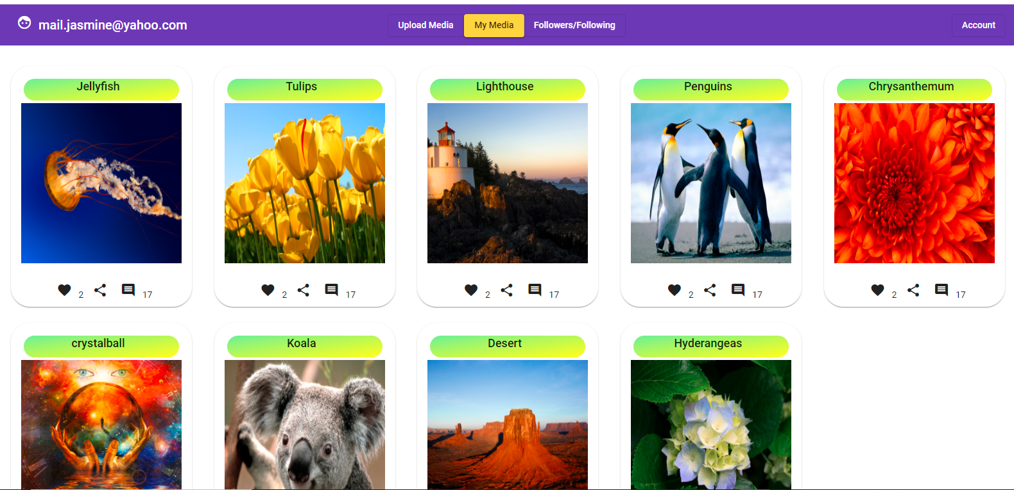

**Individual Media Details**

